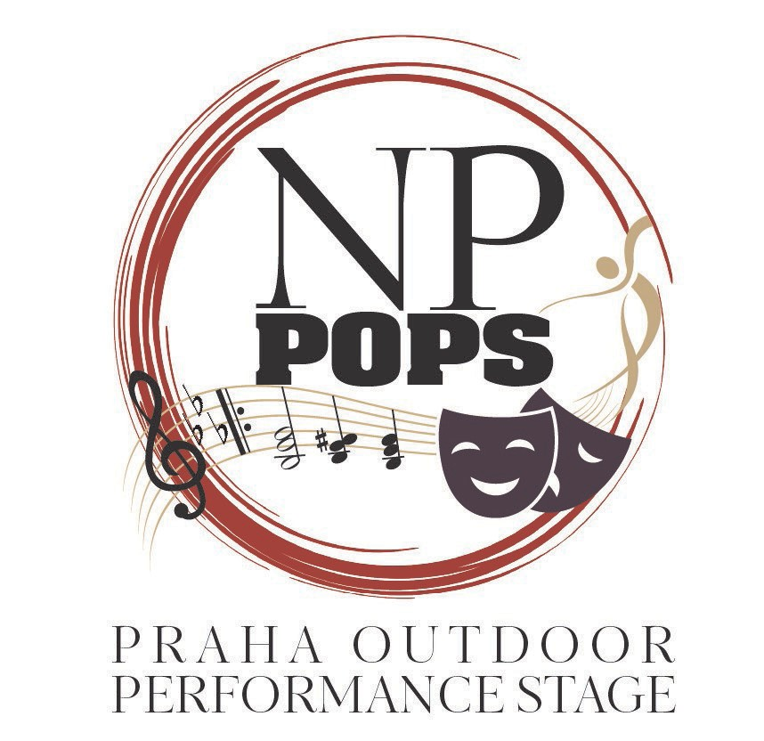
Fundraising Proposal May 2023

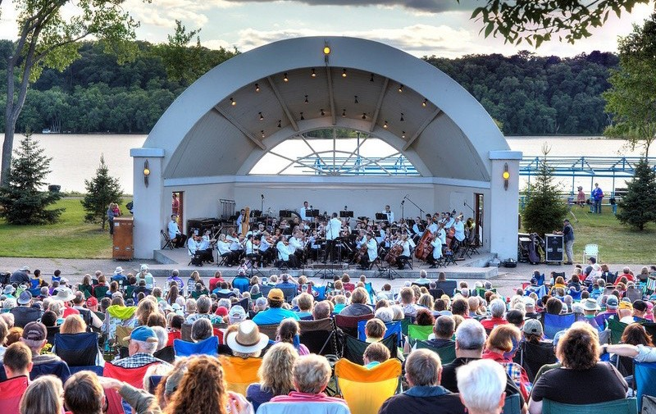
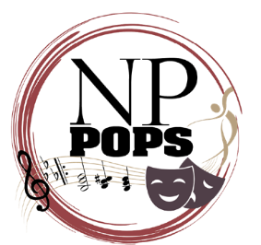

Each year the NPAAC manages Music at the Broz, a summer outdoor concert series; the Dozinky Variety
Show on Saturday night of Dozinky weekend; sponsors a youth art and activities night each spring with the New Prague Area Education Foundation; and makes grants to community arts organizations.

The New Prague Area Arts Council (NPAAC) was the lead non-profit organization, through its Praha Outdoor
Performance Stage (POPS) Committee, in this much-needed project for New Prague. In April 2023, the NPAAC voted to move all activities for POPS to the new non-profit 501c3 tax exempt organization The Forward New Prague Foundation. The NPAAC is still actively involved in this effort. The city is donating the land for the outdoor facility.

It’sTimeme Time”
Hudson, WI - Outdoor Performance Facility - This could be New Prague!
Cities throughout Minnesota encourage and entertain arts lovers throughout the year at
outdoor venues to promote those interested in performing to the public. New Prague, a vibrant city of 8,100 people, has no outdoor performance space. A private effort is underway to raise $1 million to change that!
“It’s Time” is the catch phrase for a community-wide effort to make this type of facility a reality in New
Prague. Today, we would like to discuss why you should get invested and be invested in supporting this effort to build the historic Praha Outdoor Performance Stage (POPS) in New Prague in the next few years.

The POPS Committee has been meeting since late 2021 with city officials, school officials, arts groups and other community leaders.
Page 2 | Praha Outdoor Performance Stage Proposal

.
The organization formally began its work in April of 2022 and began fundraising in October. In its infancy, it has accomplished an amazing amount;
of work. For example:

.•

You are a leader in this community. Leaders, simply, make things happen and others see that leadership and
want to be part of something good for the community. Another way to leave a legacy in this community and look ahead to what serves the public good and makes New Prague a great place to live, work and play.
We ask today that you review our proposal and be part of this great effort to see our community rise to the
occasion and provide funding for a facility of this type.
Page 3 | Praha Outdoor Performance Stage Proposal

- ……As of spring 2023, pledges are near $400,000. Our goal is to reach $500,000 by the end of 2023, raising an additional $500,000 in 2024 and 2025 to reach $1 million in private funding.
- The New Prague Park Board has allocated $5,000 to the POPS Committee to assist in paying for a site feasibility study. The POPS Committee has selected Bolton & Menk as the architectural/engineering firm for that work. That will be completed by summer 2023.
- In working with the city, the group has looked at a number of city-owned sites and narrowed the selection down to three areas. See information later in this proposal regarding those sites.
- Funds collected for the POPS facility are now being accepted through the Forward New Prague Foundation (FNPF), which has recently received 501c3 tax-exempt status from the IRS. The New Prague Area Arts Council (NPAAC) has officially moved all its activities of the POPS Committee to the FNPF.
- Personal visits have been made to a number of outdoor community facilities in Minnesota as research for what is appropriate and doable for New Prague.
- Between 15-20 potential large donors have been initially contacted to gauge interest in the project since November 2022. The results have been very positive. Efforts also will be made to look at private and public grants.

- To complete a long-standing need of New Prague to provide this type of venue for community use.
- Creating outdoor arts events in New Prague with a tent/canopy is not a long-term solution. The long- term solution is a PERMANENT STRUCTURE!
- To collaborate with the city, school, community organizations, other community leaders and arts’ groups to build a venue the community can be proud of together.
- To provide a venue for family entertainment throughout the year, including concerts, theatre and dance productions, church events, family movies, weddings/anniversaries and so much more!
- To create a facility that’s a showcase for the southwest metro area that shines a positive light on the community.

Why are We Undertaking this Effort and Why Should You Be Involved?

Page 4
| Praha Outdoor Performance Stage Proposal

The Praha Outdoor Performance Stage Committee has created and will governed by the following:
Page 5 | Praha Outdoor Performance Stage Proposal

OUR MISSION STATEMENT
“To build a multi-purpose outdoor performance facility to celebrate the arts and other community gatherings from music to theatre to dance to visual arts and much more.”

OUR VISION STATEMENT
“The venue will strive to be an attractive community asset, well-designed acoustically for the performing arts and community gatherings; comfortable for the performers and spectators, accommodating to those with disabilities, and facilitating from small, up to large groups of attendees and performers.”

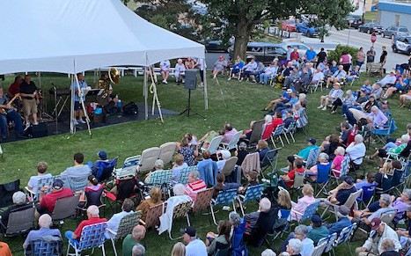
Who Will Use This Facility?
Another common question we receive is who exactly will use this outdoor facility. Use of the POPS would be
widespread. Some would include:
•
•
•
•
•
•
•
•
•
•
•
•
•
•
•
•
•
•
New Prague Community Band
Local City Choral Groups
Music at the Broz Summer Concert Series Dance Events
Theatre Events
Family Events (e.g. “Movie Night”) Print/Sculpture Art Exhibitions Staging for Half Marathon Awards Chamber Events throughout the year NP Historical Society programs Exercise Classes
Community Education Programming Library Programming
Scout Programming School District Activities
Churches for Special Programming
Wedding and other Special Group Events (Revenue-Raising Opportunities) Other Miscellaneous Groups
Page 6
| Praha Outdoor Performance Stage Proposal

POPS Committee
Who are some of the members of the POPS Committee of the New Prague Area Arts Council? They are leaders from the community, city leadership, school district, arts enthusiasts and more.
POPS Officers and Leadership Team:
Officers
•
•
•
•
Den Gardner, Chair
Karen Steinhoff, Vice Chair
Bruce Wolf, Treasurer/Financial Officer Sandi Loxton, Secretary
Leadership Team
•
•
•
•
•
•
•
•
•
•
•
Steve Frost
Andy Beckius Dr. Jon Colling Joe Barten Lisa Brusseau
Shannon Brusseau Brooke Sticha Tony Buthe
Julie Schmitz Ben Hilding Larry Pint
Page 7
| Praha Outdoor Performance Stage Proposal

Location, Location, Location
The location of the POPS is a key element in the building process. The city officials of New Prague, through its Park Board, are suggesting a handful of sites that might be appropriate for construction of the POPS.
The POPS Committee is vitally interested in input from city residents about the location of the facility. There are
a number of areas of property under consideration. These are the areas that are currently being investigated (in no particular priority at this time):
•
•
•
City Center (west end of downtown; old Mill Pond/Creamery site).
Sliding Hill Skate Park (across from New Prague High School)- will not affect sliding hill. Memorial Park area.
Page 8
| Praha Outdoor Performance Stage Proposal

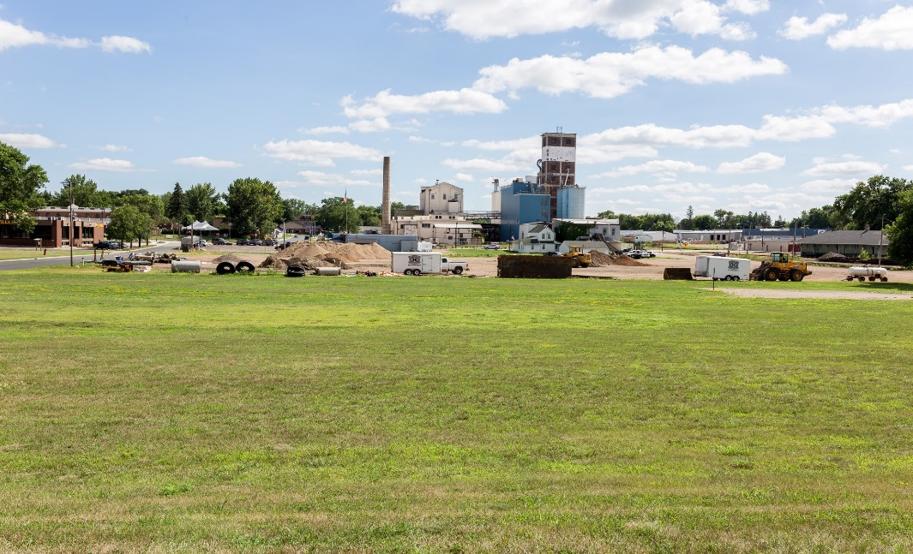
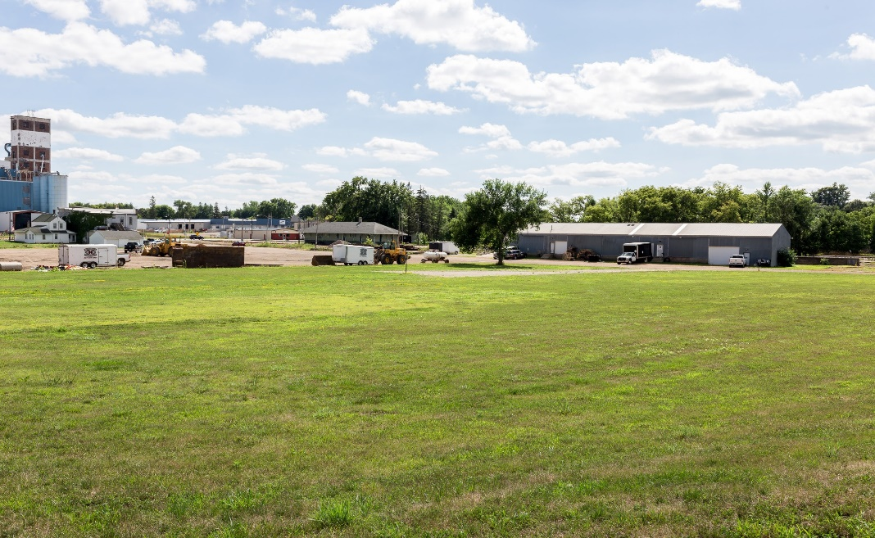
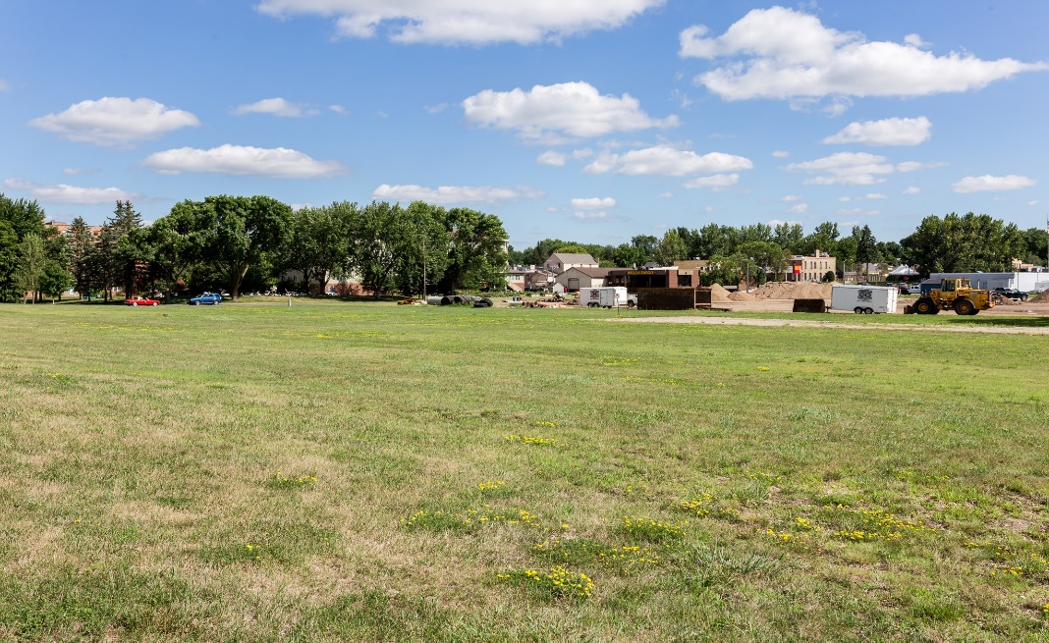
City Center
(West end of downtown; old Mill Pond/Creamery site.
Page 9 | Praha Outdoor Performance Stage Proposal

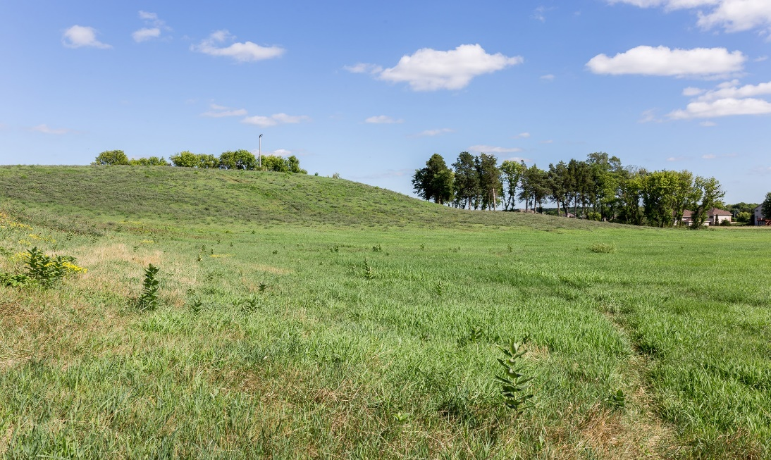
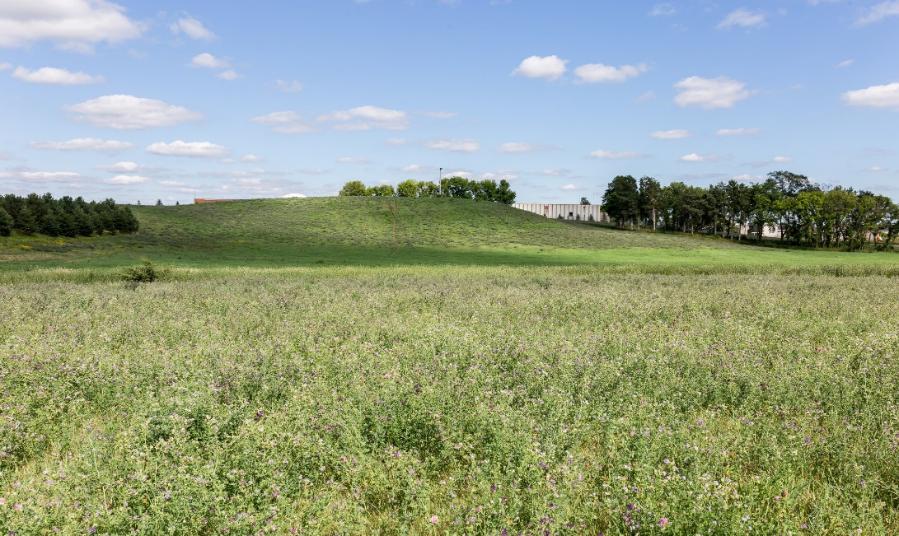
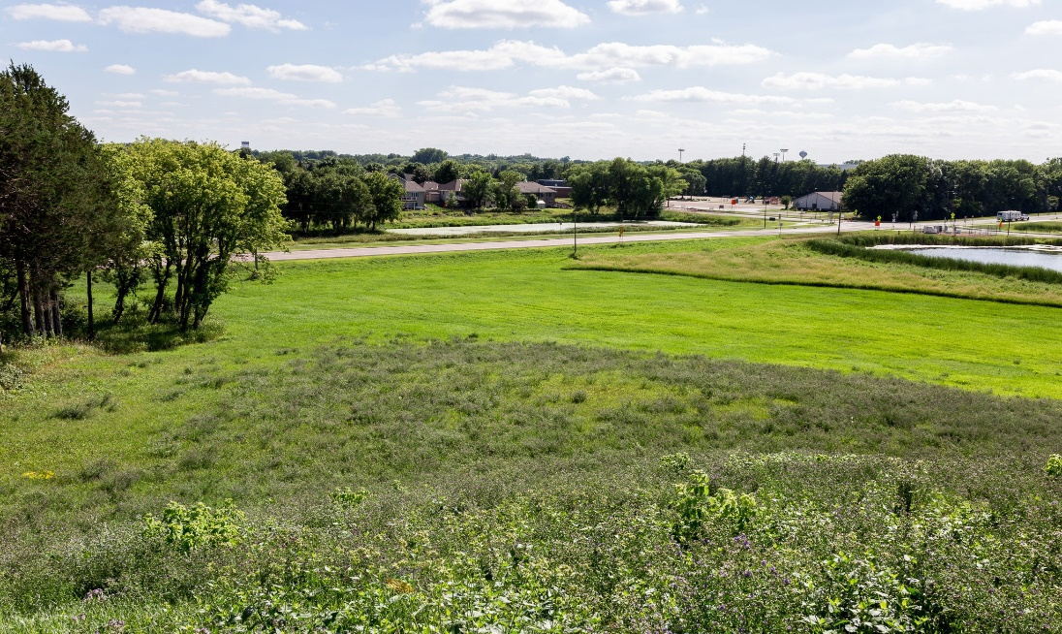
Sliding Hill
(Across from New Prague High School - structure would NOT affect sliding hill)
Page 10 | Praha Outdoor Performance Stage Proposal

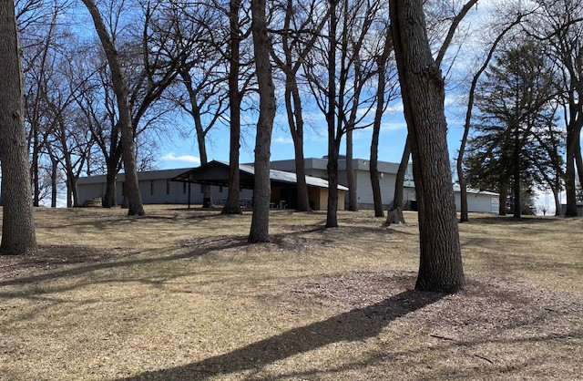
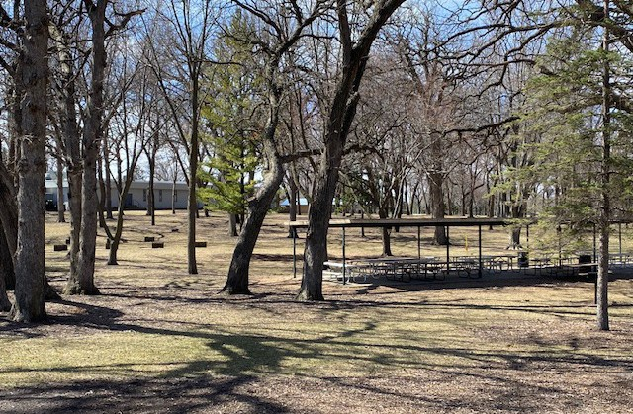
Memorial Park Area
Page 11 | Praha Outdoor Performance Stage Proposal

“IT’S TIME” To Raise Funds
The majority of our funding for this effort will be through private funding WITH THREE-YEAR PLEDGES. Our group is working with the city and public and private grants will be applied for over the next couple years. (The New Prague city administrator, community development director, city planner and others city staff are working with our committee on a regular basis.
But we are clear in our goal to raise the vast majority of our funding with private dollars.)
As noted earlier, the chair of the POPS Committee is Den Gardner, chair of the New Prague Area Arts Council
(and a member for 20+ years). Den has been active in the New Prague community since moving here 30 years ago, serving on the golf board, active in church activities and a business owner in New Prague since 1995 (Gardner & Gardner Communications). Den also manages and plays in a local New Prague band – Little Chicago – which has performed in New Prague and the surrounding area for 20+ years with several other New Prague musicians.
To show their commitment to this project, Den and his wife Sandy have pledged $100,000 to this project
We merely ask that you review our materials in the ensuing pages and consider a major donation over three years for this project.
Page 12 | Praha Outdoor Performance Stage Proposal

The Fundraising Offer
The fundraising goal is $1 million raised in THREE-year pledges in Phase I.
Phase II is $500,000 in year four (and five if necessary).
Phase I
•
Creating an organizing committee through New Prague Area Arts Council to develop a plan for building
facility. (Done)
Develop an ongoing relationship with the city of New Prague to deal with numerous issues, including infrastructure and future maintenance of the facility. (Ongoing)
Develop an ongoing relationship with Independent School District 721 to facilitate opportunities for numerous arts groups to use the facility. (Ongoing)
Create web site and social media platforms (Facebook/Instagram/Twitter) to provide information about the project and raise money for its completion. (Done)
Initiate creation of an IRS-approved 501c3 non-profit to incorporate this project and future community projects. (Done)
Begin processes to:
» Work with the city to find a suitable area for construction. (Ongoing)
•
•
•
•
•
»
»
Hire an architectural/engineering firm to design and construct the facility. (Done)
Develop collaborations with city/school/business/community leaders to create a cohesive plan to meet community needs of its citizens. (Ongoing)
Investigate public/private grant opportunities with the city and others to supplement private funding. (Ongoing)
»
•
Raise $1 million in three years (through pledges/immediate contributions)
Phase II
The intent is that Phase I will involve the construction of the basic facility. Phase II, still in development, will include:
•
•
•
•
•
Possible Amphitheatre seating
Full landscaping Full hardscaping
Maintenance of the facility (costs absorbed beyond what city might provide) Other necessary improvements
The planned financial goal of Phase II is $500,000
Page 13 | Praha Outdoor Performance Stage Proposal

Giving Levels of Support and Your Benefits for Supporting This Effort
Donations will be secured from individuals and businesses. It is clear that the altruistic reasons to be a significant contributor of this effort differ between an individual and a corporation. Thus, the various levels below are intended only to be a guide for those considering financially supporting this effort in a significant way.
Please know that your donation is to a 501c3 non-profit organization and you will accrue all the appropriate tax benefits that accompany a donation to a non-profit of this kind.
Also, the level in which you determine to participate can be specifically tailored to your needs.
clear we are flexible. We are ready to sit down and discuss how we can work together.
We want to be
Diamond -- $100,000+
•
•
•
•
•
•
•
•
•
•
•
•
Diamond Signage at building site (size TBD)
Listing on web page
News release announcing donation
Feature article/interview on donors as appropriate Listing in all e-newsletters produced by committee Recognition on social media as appropriate Inclusion in annual report
Public address announcements at events (as appropriate) T-shirt recognizing support of POPS
Tumbler with POPS logo and your name Pavers (brick) at site with your name
Invitation to an annual donor-only recognition event
Platinum -- $75,000+
•
•
•
•
•
•
•
•
•
•
•
•
Platinum Signage at building site (size TBD)
Listing on web page
News release announcing donation
Feature article/interview on donors as appropriate Listing in all e-newsletters produced by committee Recognition on social media as appropriate Inclusion in annual report
Public address announcements at events (as appropriate) T-shirt recognizing support of POPS
Tumbler with POPS logo and your name Pavers at site with your name
Invitation to an annual donor-only recognition event
Gold -- $50,000+
•
•
•
•
•
•
•
•
•
Gold Signage at building site (size TBD)
Listing on web page
News release announcing donation
Feature article/interview on donors as appropriate Listing in all e-newsletters produced by committee Recognition on social media as appropriate Inclusion in annual report
Public address announcements at events (as appropriate) T-shirt recognizing support of POPS
Page 14 | Praha Outdoor Performance Stage Proposal

•
•
•
Tumbler with POPS logo and your name
Pavers at site with your name
Invitation to an annual donor-only recognition event
Silver -- $25,000+
•
•
•
•
•
•
•
•
•
•
•
•
Silver Signage at building site (size TBD)
Listing on web page
News release announcing donation
Feature article/interview on donors as appropriate Listing in all e-newsletters produced by committee Recognition on social media as appropriate Inclusion in annual report
Public address announcements at events (as appropriate) T-shirt recognizing support of POPS
Tumbler with POPS logo and your name Pavers at site with your name
Invitation to an annual donor-only recognition event
Bronze -- $10,000+
•
•
•
•
•
•
•
•
•
•
•
•
Bronze Signage at building site (size TBD)
Listing on web page
News release announcing donation
Feature article/interview on donors as appropriate Listing in all e-newsletters produced by committee Recognition on social media as appropriate Inclusion in annual report
Public address announcements at events (as appropriate) T-shirt recognizing support of POPS
Tumbler with POPS logo and your name Pavers at site with your name
Invitation to an annual donor-only recognition event
Patron -- $5,000+
•
•
•
•
•
•
•
•
•
•
•
•
Patron Signage at building site (size TBD)
Listing on web page
News release announcing donation
Feature article/interview on donors as appropriate Listing in all e-newsletters produced by committee Recognition on social media as appropriate Inclusion in annual report
Public address announcements at events (as appropriate) T-shirt recognizing support of POPS
Tumbler with POPS logo and your name Pavers at site with your name
Invitation to an annual donor-only recognition event
Page 15 | Praha Outdoor Performance Stage Proposal

Supporter -- $2,500+
•
•
•
•
•
•
•
Supporter Signage at building site (size TBD)
Listing on web page
News release announcing donation
Listing in all e-newsletters produced by committee Recognition on social media as appropriate Inclusion in annual report
Tumbler with POPS logo and your name
Friend -- $1,000+
•
•
•
•
•
•
•
Friend Signage at building site (size TBD)
Listing on web page
News release announcing donation
Listing in all e-newsletters produced by committee Recognition on social media as appropriate Inclusion in annual report
T-shirt recognizing support of POPS
In addition to personal presentations soliciting funds for this tax-deductible venture in New Prague, other
fundraising efforts will be ongoing simultaneously. One example is a vehicle giveaway in the fall of 2023.
Phase I – Year One, Two & Three:
•
•
•
Year One -- $500,000 (by the end of 2023)
Year Two -- $250,000 (by the end of 2024)
Year Three -- 250,000 (by the end of 2025)
Phase II – Year four:
•
Year Four $500,000
Money to be raised will come through:
•
•
•
•
•
•
•
•
•
Mail solicitations
Email solicitations Personal solicitations
Foundation grant solicitations Phone solicitations
Donations through the web site (www.nppops.org) Donations received from another organization’s website Government grant/solicitations
Other
» Special events
»
»
Business donations through retail sales
Silent auctions/raffles, etc.
Page 16 | Praha Outdoor Performance Stage Proposal

Your Leadership and Your Giving
We believe the benefits of POPS in New Prague will benefit families in the area and be a truly valuable building to enhance the quality of life of our residents and visitors. We trust your leadership, interest in benevolence
in this community and altruism for what’s good and right for New Prague will put you on a path to serious consideration of a major gift to us.
As noted earlier, to recap, donations can now be made to the Forward New Prague Foundation (FNPF). The POPS Committee is now being managed within this new 501c3 tax exempt non-profit organization.
For additional specific information about the project, go to www.nppops.org. Or contact the chair the NPAAC and POPS Committee.
DEN GARDNER
Email: dengardner@gandgcomm.com PCell: 612-325-3981

Th

Page 17 | Praha Outdoor Performance Stage Proposal

